
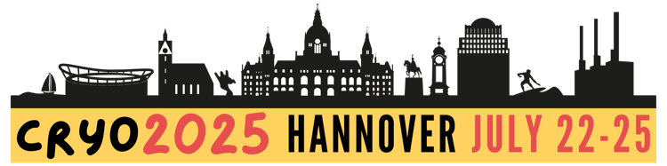
SPONSORSHIP & EXHIBITION AGREEMENT
Please return this form to admin@societyforcryobiology.org
CONTACT DETAILS
Company Name: |  |  | Company Website
Contact Name: |  |  | Contact Telephone:
Contact Email:
Street Address:
City: |  |  | State: |  | Postcode:
Country:
SPONSORSHIP LEVEL & EXHIBITION
Diamond  $12,000 | Platinum  $10,000 | Gold  $8,000 |  | Silver  $6,000 |  | Bronze  $4,000 | Supporter  $2,000
Premium Placement Exhibition Included | Exhibition Included | Exhibition Included |  | Add Silver Exhibition  + $1,250 |  | Add Bronze Exhibition +$1,625 | Add Supporter Exhibition +$2,000
Or Standalone Exhibition - $2,500
SPONSOR’S CHOICE
Please select an item of your choice from any category up to and including your sponsor level, eg a Gold sponsor can choose from Bronze, Silver or Gold Items.
*Item to be provided by sponsor at sponsor’s cost. 250 maximum quantity required. Item design to be approved by the organizing committee.
DIAMOND  Banquet Sponsorship  Lunch Workshop or Symposium | PLATINUM  Lunch Sponsorship  Lanyard Sponsorship^*  Poster Session Sponsorship | GOLD  Coffee Break Sponsorship |  | SILVER  Pen Sponsorship  Notebook Sponsorship  1 complimentary Virtual Delegate Registration |  | BRONZE  Delegate Bag Item*  Delegate Bag Insert*  1 complimentary Virtual Delegate Registration
COMPANY PROFILE & LOGO
Company Profile For the CRYO2025 website, event app, and program book (limit 100 words)
Company Logo
Please email a high resolution, transparent .png file (preferred) when you return this form. .jpg and .svg are also acceptable.
ACKNOWLEDGEMENT
I acknowledge I will receive the items listed on the following page according to my selected sponsorship level.
Signature: |  |  |  | Date:

